Sam McDowell

7/3/2020

Lab 3.2

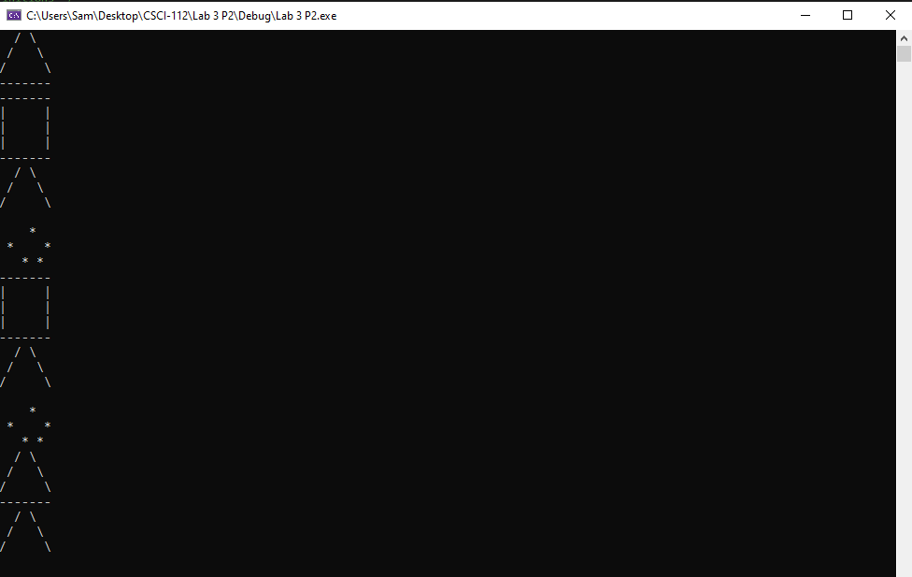

# Transcription:

/ \

/ \

/ \

-------

-------

| |

| |

| |

-------

/ \

/ \

/ \

*

* *

* *

-------

| |

| |

| |

-------

/ \

/ \

/ \

*

* *

* *

/ \

/ \

/ \

-------

/ \

/ \

/ \